- Says on the Silicon board 2004A
- I2C bus is a type of serial bus invented by PHLIPS.
- It is a high-performance serial bus which has bus ruling and high or low speed device synchronization function required by multiple host system.
- I2C bus has only two bidirectional signal lines:
- Serial Data Line (SDA)
- Serial Clock Line (SCL)
- Contains blue potentiometer:
The I2C LCD2004 is used to adjust the contrast (backlight) to make it easier to display on the I2C LCD2004.
Increased: Clockwise
Decreased: Counter-clockwise

Backlight/Contrast
- Jumper Cap
- Enable Backlight: Jumper cap connected
- Disable backlight: Jumper cap disconnected (Unplugged)

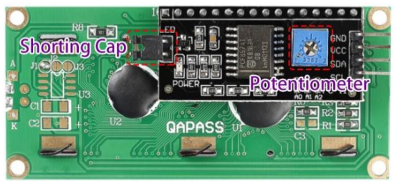

I2C Address
- Default address: 0x27
- Addresses for some case: 0x3F
- Address Modification: By shorting the address pads (A0, A1, A2)
  - Default: A0/A1/A2 is 1
  - Shorted: A0/A1/A2 is 0
Pin Connections
PIN | Description | Connection
GND | Ground
VCC | Voltage supply | 5V
SDA | Serial data line | Connect to VCC through a pull_up resistor
SCL | Serial clock line | Connect to VCC through a pull_up resistor

